MACHINE PROBLEM NO. 4 SANTOS, MIKAELA

PROOF OF TESTING TUPINO, DIEGO

TEST 1: IDEAL

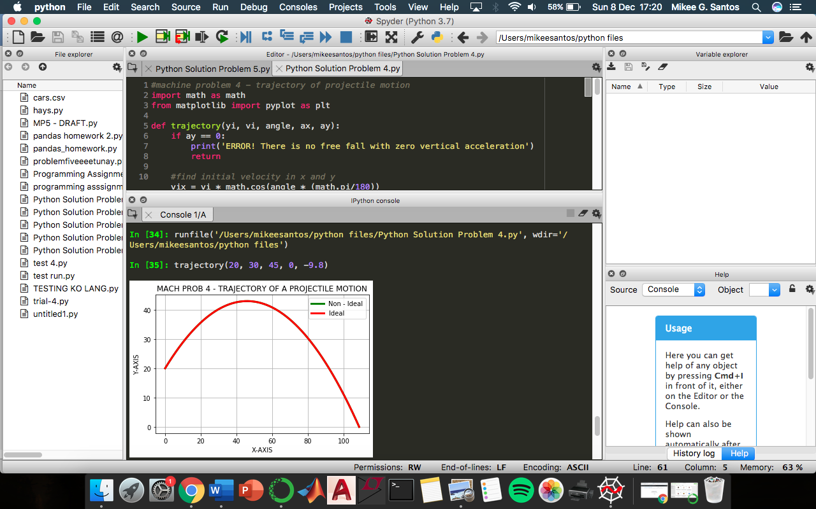

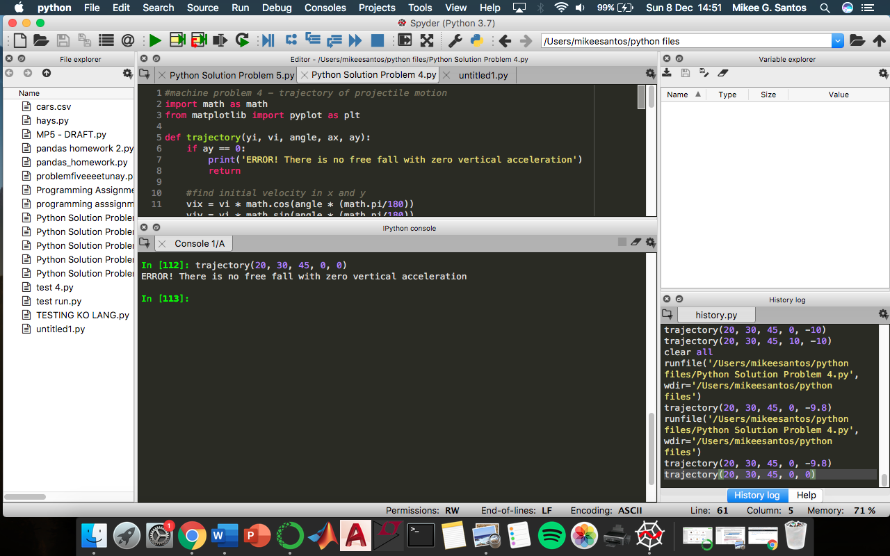

TEST 2: ERROR (0 VERTICAL ACCELERATION)

TEST 3: NON-IDEAL

* with ax

